Submission code: (to be given by the conference organizer)
Instructions for the Preparation of Paper (Paper Title font size 12 points)

First Name Family Name (make the first author’s name in the boldface only when this author is a student and hopes to compete for the Best Student Paper Awards)ª, John Smith^{b}*, John Lee^{c}
ª Department of International Trade, Jeonbuk National University, Jeonju-si, Jeollabuk-do, Republic of Korea. Email address: author@abc.edu.co
^{b} Department of Logistics Management, ABC University, City, Country; * Corresponding author, Email address: author@abc.edu.co
^{c} Department of XYZ, DEF University, City, Country. Email address: author@abc.edu.co

Abstract (font size 12 points)

This document contains guidelines for preparing the expanded abstracts for the GRN-BRI 2026 to be held on 26-28 November 2026 at Jeonbuk National University, Korea. The font size for the paper title is 12 points and that for the text is 11 points. The expanded or full paper should cover its research background, methodology to be employed and its significance. Authors are advised to submit their paper(s) to ( )by email. The length of a paper should be between 5 to 8 pages in English. All the papers will be peer-reviewed and only accepted papers will be presented at the Conference. Best Student Paper Awards will be presented to selected presentations with the submission of full papers. Note that a student should be the first author of the paper that will be considered for the Award.

Keywords: (limited to five keywords only) See examples of reference style below.
Smart Port, Warehousing, River-Sea combined transport

Introduction (font size 12 points)

Authors may determine the sessions according to their paper contents.

Table 1. Example of tables

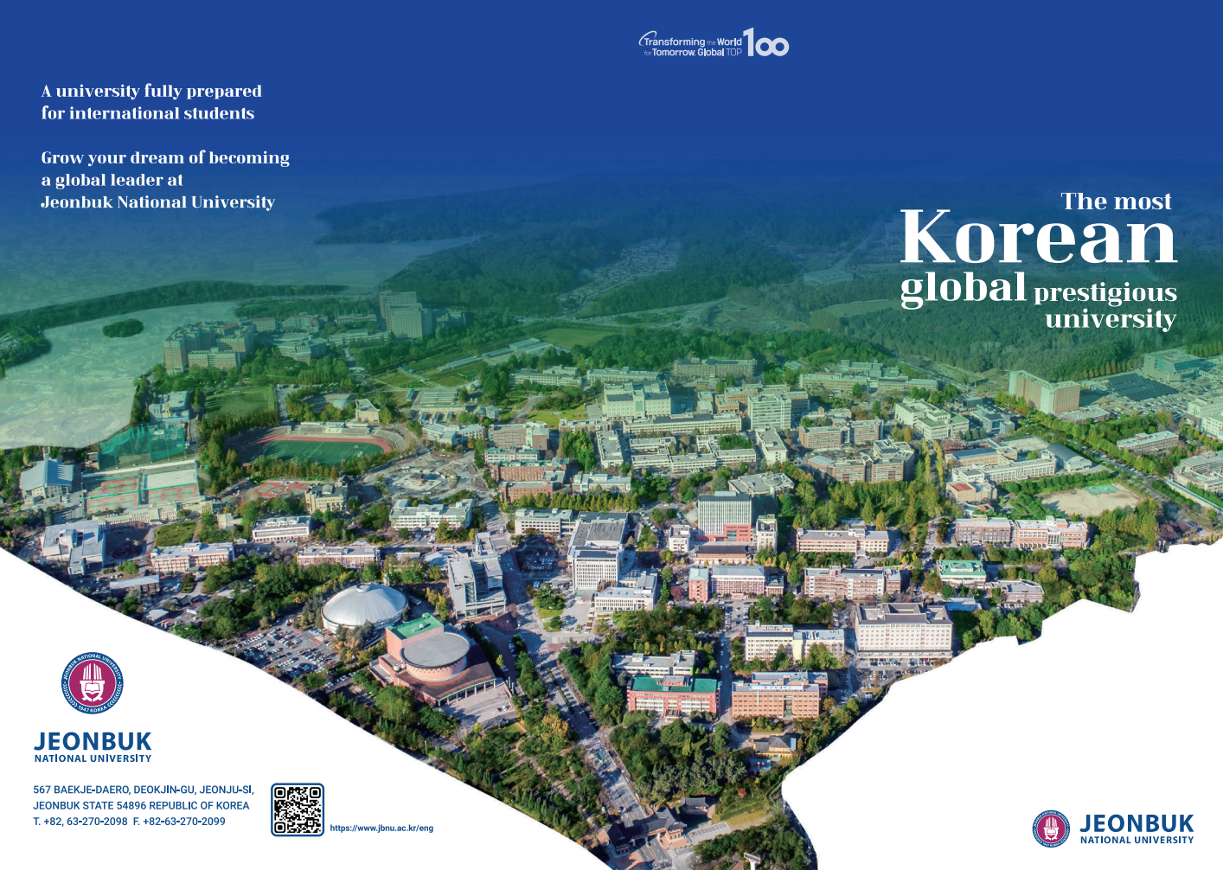

Figure 1. Example of figures

Literature review

The citation format of Maritime Policy & Management is recommended for the submissions to the Conference (https://www.tandfonline.com/toc/tmpm20/current).

Acknowledgements

References (See examples of reference style below.)

Chen, J.K., Kim, Y.S., Lim, S. and Patton, J., 2018. River-Sea Combined Transport. Journal of International Maritime Transport, 24(1), 123-130.
Smith, J. and Gratton, P., 2016. Dynamics of Logistics in the Globalized Economy. Published city: Publishing Company.
(* In case of website citation, please indicate accessed date after the website.)

